**Part A: Tournament Stats**

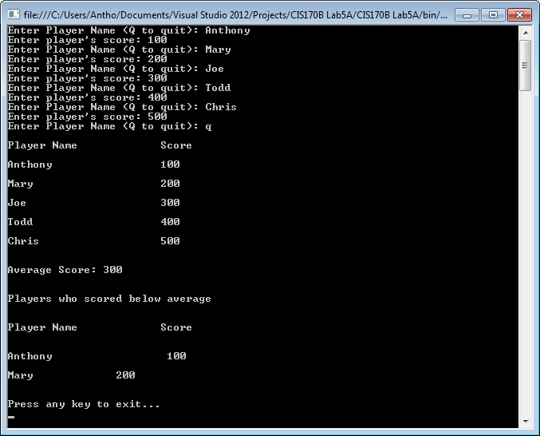

// ---------------------------------------------------------------

// Programming Assignment: LAB5A

// Developer: Anthony Meunier

// Date Written: 8/9/2014

// Purpose: Tournament Stats

// ---------------------------------------------------------------

using System;

using System.Collections.Generic;

using System.Linq;

using System.Text;

using System.Threading.Tasks;

namespace CIS170B_Lab5A

{

class Program

{

static void Main(string[] args)

{

string[] playerName = new string[100];

double[] score = new double[100];

int numPlayers = 0;

double averageScore;

InputData(ref playerName, ref score, ref numPlayers);

DisplayPlayerData(playerName, score, numPlayers);

averageScore = CalculateAverageScore(score, numPlayers);

DisplayBelowAverage(playerName, score, numPlayers, averageScore);

Console.WriteLine("\n\nPress any key to exit...");

Console.ReadKey();

}

static void InputData(ref string[] playerName, ref double[] score, ref int numPlayers)

{

while (numPlayers < playerName.Length)

{

Console.Write("Enter Player Name (Q to quit): ");

playerName[numPlayers] = Console.ReadLine();

if (playerName[numPlayers] == "Q" || playerName[numPlayers] == "q")

{

break;

}

Console.Write("Enter player's score: ");

score[numPlayers] = Convert.ToDouble(Console.ReadLine());

numPlayers++;

}

}

static void DisplayPlayerData(string[] locPlayerName, double[] locScore, int totalPlayers)

{

Console.WriteLine("\nPlayer Name\t\tScore\n");

for (int i = 0; i < totalPlayers; i++)

{

Console.WriteLine(locPlayerName[i] + "\t\t\t" + locScore[i] + "\n");

}

}

static double CalculateAverageScore(double[] locScore, int totalPlayers)

{

double totalScore = 0, avgScore = 0;

for (int i = 0; i < totalPlayers; i++)

{

totalScore += locScore[i];

}

avgScore = totalScore / totalPlayers;

Console.WriteLine("\nAverage Score: " + avgScore);

return avgScore;

}

static void DisplayBelowAverage(string[] playerName, double[] score, int totalPlayers, double averageScore)

{

Console.WriteLine("\n\nPlayers who scored below average\n");

Console.WriteLine("\nPlayer Name\t\tScore\n");

for (int i = 0; i < totalPlayers; i++)

{

if (score[i] < averageScore)

{

Console.WriteLine("\n{0} \t\t {1}", playerName[i], score[i]);

}

}

}

}

}

**Part B: Alphabetical Order**

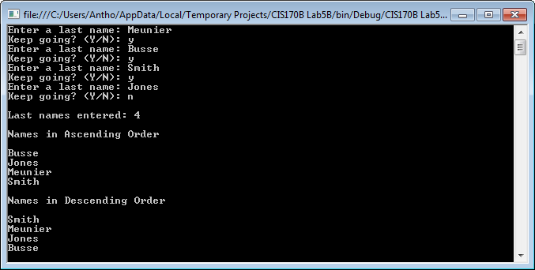

// ---------------------------------------------------------------

// Programming Assignment: LAB5B

// Developer: Anthony Meunier

// Date Written: 8/9/2014

// Purpose: Alphabetical Order

// ---------------------------------------------------------------

using System;

using System.Collections.Generic;

using System.Linq;

using System.Text;

using System.Threading.Tasks;

using System.Collections;

namespace CIS170B_Lab5B

{

class Program

{

//main function

static void Main(string[] args)

{

//instantiate arraylist object

ArrayList nameArray = new ArrayList();

//load user input from function

GetNames(nameArray);

//display count of last names

Console.WriteLine("\nLast names entered: " + nameArray.Count);

//sort arraylist

nameArray.Sort();

Console.WriteLine("\nNames in Ascending Order\n");

//loop to display names

for (int i = 0; i < nameArray.Count; i++)

{

Console.WriteLine(nameArray[i]);

}

//reverse the order of the arraylist

nameArray.Reverse();

Console.WriteLine("\nNames in Descending Order\n");

//loop to display names

for (int i = 0; i < nameArray.Count; i++)

{

Console.WriteLine(nameArray[i]);

}

Console.ReadLine();

}

//get user input until they want to quit

static void GetNames(ArrayList nameArray)

{

do

{

Console.Write("Enter a last name: ");

nameArray.Add(Console.ReadLine());

Console.Write("Keep going? (Y/N): ");

}

while (Console.ReadLine().ToUpper() == "Y");

}

}

}